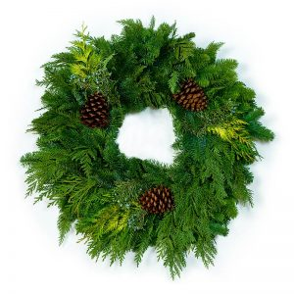
22” or 26” Rustic Wreath  ($31-$34) | 20” / 22” / 26” Deluxe Wreath with Bow ($30-$33) |  | 12” Candle Ring  ($27)
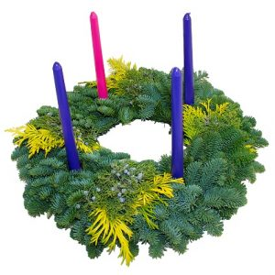 | 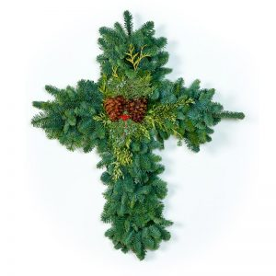
20” Advent Wreath  ($33) | 28” Deluxe Cross Wreath  ($35) |  | 28” Deluxe Door Swag with Bow  ($28)
15 ft. Cedar Garland  ($26) |  | Red Velvet Bow  ($3)

